Project Design Phase-II

Data Flow Diagram & User Stories

|  |  |
| --- | --- |
| Date | 09 November 2022 |
| Team ID | PNT2022TMID03082 |
| Project Name | AI-based localization and classification of skin disease with erythema |
| Maximum Marks | 4 Marks |

# Data Flow Diagrams:

A Data Flow Diagram (DFD) is a traditional visual representation of the information flows within a system. A neat and clear DFD can depict the right amount of the system requirement graphically. It shows how data enters and leaves the system, what changes the information, and where data is stored.

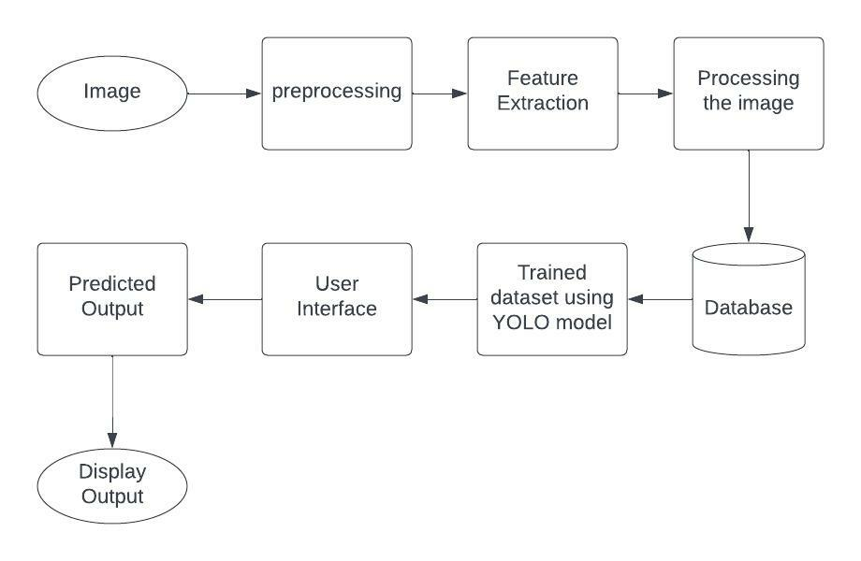

# User Stories

|  |  |  |  |  |
| --- | --- | --- | --- | --- |
| **User Type** | **Functional Requirement (Epic)** | **User Story Number** | **User Story / Task** | **Acceptance criteria** |
| Patient (Mobile User) | Registration | USN-1 | As a user, I can register for the application by entering my email, password, and confirming  my password. | I can access my account / dashboard |
|  |  | USN-2 | As a user, I will receive confirmation email once I have registered for the application | I can receive confirmation email & click confirm |
|  |  | USN-3 | As a user, I can register for the application through Gmail | I can receive confirmation email |
|  | Login | USN-4 | As a user, I can log into the application by entering email & password | I can login anytime with my login credentials |
|  | Dashboard | USN-5 | As a user, I will be informed to fill my Details | I can view and edit my information |
|  |  | USN-6 | As a user, I will be informed to submit an Image | I will get the Analyzed results |
|  |  | USN-7 | As a user, I can login anytime anywhere with network connection | I will get the Analyzed results |